CONTAINMENT ZONE ALERTING APPLICATION

**PROPOSED SOLUTION DOCUMENT**

# INTRODUCTION

The World Health Organization has declared the outbreak of the novel coronavirus, COVID-19 as pandemic across the world. With its alarming surge of affected cases throughout the world, lockdown and awareness (social distancing, use of masks etc) among people are found to be the only means for restricting the community transmission. In a densely populated country like India, it is very difficult to prevent the community transmission even during lockdown without social awareness and precautionary measures taken by the people. Recently, several containment zones had been identified throughout the country and divided into red, orange and green zones, respectively. The red zones indicate the infection hotspots, orange zones denote some infection and green zones indicate an area with no infection. This paper mainly focuses on development of an Android application which can inform people of **the COVID-19 containment zones and prevent trespassing into these zones**. This Android application updates the locations of the areas in a Google map which are identified to be the containment zones. The application also notifies the users if they have entered a containment zone and uploads the user’s IMEI number to the online database. With this IMEI number, the police can keep an eye on the people who are frequently violating the lockdown rules. Therefore, this application can be used as a tool for creating further social awareness about the arising need of precautionary measures to be taken by the people of India.

# NOVELTY OF THE PROJECT

The novel coronavirus, COVID-19 as pandemic across the world. With its alarming surge of affected cases throughout the world, lockdown and awareness (social distancing, use of masks etc) among people are found to be the only means for restricting the community transmission. In a densely populated country like India, it is very difficult to prevent the community transmission even during lockdown without social awareness and precautionary measures taken by the people. Recently, several containment zones had been identified throughout the country and divided into red, orange and green zones, respectively. The red zones indicate the infection hotspots, orange zones denote some infection and green zones indicate an area with no infection. This paper mainly focuses on development of an Android application which can inform people of the COVID-19 containment zones and prevent trespassing into these zones. This Android application updates the locations of the areas in a Google map which are identified to be the containment zones. The application also notifies the users if

they have entered a containment zone and uploads the user’s IMEI number to the online database. With this IMEI number, the police can keep an eye on the people who are frequently violating the lockdown rules. To achieve all these functionalities, many tools and APIs from Google like Firebase and Geofence are used in this app. Therefore, this application can be used as a tool for creating further social awareness about the arising need of precautionary measures to be taken by the people of India.

A similar kind of mobile tracing application has been developed in India, namely, Aarogya Setu . The App is designed in such a way that it informs the user whenever they come in contact with an infected person through Bluetooth and GPS location services. The data acquired from the application is not disclosed publicly and is only used by the government for tracing, tracking, and management of COVID-19. There are necessary steps that need to be followed by the users to use the Aarogya Setu application by logging into the App using a one-time password and filling out basic demographic details of the users to suggest whether the user is in safe vicinity or not. Given the foreign travel history, if it exists for the user, it is matched with those who have been tested positive for COVID-19 with the help of the **Indian Council of Medical Research (ICMR) database.**

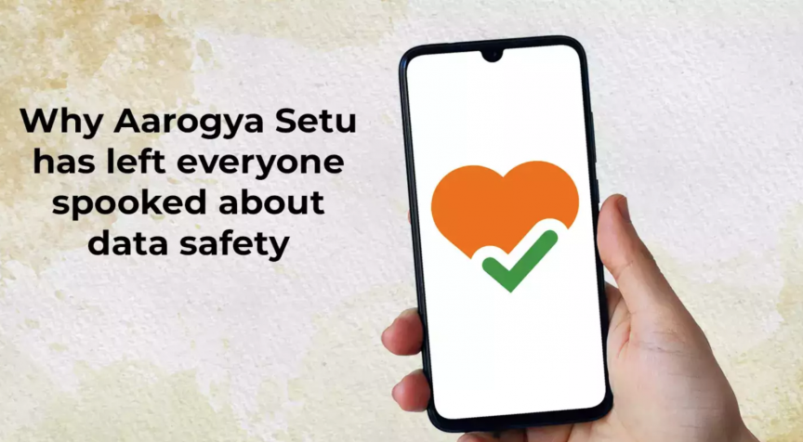

.

The application has been designed in such a way that it informs the users through notification if they cross paths with a COVID-positive person. The tracking is accomplished with the help of Bluetooth technology and location-generated social graphs or GPS, which shows the user's interaction with anyone who has been tested coronavirus positive and notifies them. It detects and tracks the user's movement with the help of GPS and Bluetooth sensors. It will also discover other nearby smartphones that also have the application installed and then sends out a notification if they come in contact with infected people by using its database and algorithms. The App also provides essential instructions on how to self-isolate and what should be done in case anyone develops symptoms. The App recommends to keep the Bluetooth and the Location services on at all times. To use the application, one must register with a mobile number by verifying through an OTP.

A form in the App asks for personal details from the user, such as name, age, occupation, foreign travel history in the last 30 days, and other profiling

information. There is also a “Self-Assessment Test” feature on the Aarogya Setu.

Application in which some questions related to the health and symptoms of the user are asked, and based on the answers, the application shows the risk level for the user in different color codes. There is no risk if it indicates **green color code** and the text shows “**You are safe.**” There is **low risk** if it shows **yellow color code** and the version shows “You are at moderate risk.” There are **high chances of risk** if it shows an **orange color code;** then the user must contact the help-line number given in the App.

The application also suggests specific actions that can be taken

to stop the spread of coronavirus, such as social distancing, taking care of hygiene, and staying at home as precautions. As mentioned in the application's privacy policy, the data that is acquired through the form is shared only with the Government of India and will not be disclosed to any third party. The data will provide support to the government for taking appropriate steps and initiate the isolation procedure, if necessary. The name and number of the user will not be disclosed publicly.

# FEASIBILITY OF CODE

B**luetooth-based tracking apps** have a lower false-positive rate, consume less power, and have a better standard of adoption than GPS-based tracking apps. Besides the privacy concerns regarding GPS tracking, GPS data is inaccurate and unavailable inside buildings . **Bluetooth** is used by **57% of contact-tracing apps**, whereas **43% of the apps use GPS** . There is a significant trade-off between information and privacy in GPS-based applications. While privacy is a big concern, applications that use only Bluetooth cannot provide information about the geographical movement of people, which is crucial for contact-tracing.

**Contact-tracing applications** that use both Bluetooth and GPS are much more useful than applications that use only Bluetooth. Location data coupled with proximity history can help health authorities in identifying exposure trails with higher accuracy.

**Proximity-based apps** can generate a lot of false negatives and false positives. Distance is estimated based on the attenuation of the wireless signal in free space. However, the signal can also be largely attenuated by human bodies. If two individuals are standing with their back towards each other, the signal can

become weak, and the distance between them can be misinterpreted, resulting in a false negative.

The accuracy of the App depends on the positioning of smartphones concerning each other (e.g., whether the phone is in one's bag or hands). For example, a thin wall across two apartments may not attenuate the signal enough, and it could result in a proximity event, even when it is not. False positives can lead to the isolation of unaffected people, and false negatives hamper the main objective of the application . More evidence on the effectiveness of proximity tracing tools such as Bluetooth and GPS has been referred, as proximity is not solely responsible for contagion; the risk may be dependent on other independent factors such as being in an enclosed or open space. A limited user base, attributed to the low rate of adoption, can significantly reduce the effectiveness of the App [16]. Bluetooth-based apps rely on the Neighbor Discovery protocol provided by smartphones. Hence, the accuracy of discovery and emission of signals varies significantly in different smartphones.

The protocol determines the level of energy consumption (i.e., how long the battery will last), the reliability of operation when multiple phones are close to the cell's receptor, and how quickly two phones can discover each other when they come nearby

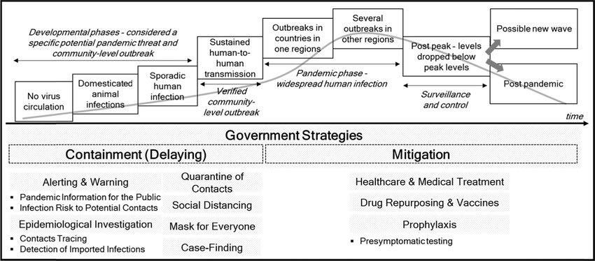

**Data Destruction:** The data that the App collects should be automatically deleted in a reasonable amount of time (maximum 30 days), or the App allows users to delete their own data manually. Some countries that automatically destroy the data are Australia, Canada, India, Israel, Italy, and Japan. Countries that do not destroy the data are Belgium, China, France, Germany, and UK.

**Transparency**: It can take the form of clear, publicly available policies and design, an open-source code base. Countries whose apps are transparent are Austria, Canada, India, Israel, Poland, and Singapore. Apps that are not transparent belong to Australia, China, France, Malaysia, and Norway.

**Limitations on Data Collection:** Data may sometimes be used for purposes other than public health such as law enforcement—and that may last longer than COVID-19. Countries that are limited in Data Collection: Australia, Bulgaria, Denmark, Israel, and Switzerland. Countries that have not limited Data Usage: Algeria, Belgium, China, Finland, and Hungary. For India, it is not clear.

Underlying Technology: Some apps identify a person's contacts by tracking the phone's movements like GPS. Some systems use “proximity tracking,” in which phones swap encrypted tokens with any other nearby phones over Bluetooth.

Many apps rely on the standard API that Apple and Google are developing. Some use DP-3T, which is a decentralized privacy-preserving proximity tracing.

Countries that are using only Bluetooth technology for locations include Australia, Czechia, and France. Austria and Belgium uses Bluetooth along with the common API from Google or Apple. India used both Bluetooth and GPS.

# BUSINESS MODEL

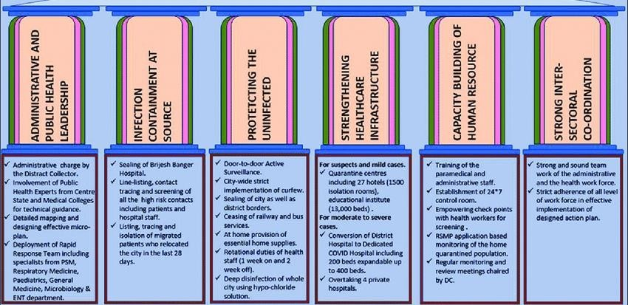

**SOCIAL IMPACT**

* This app tracks your location and helps you see whether any person is infected with Corona in your area through the Bluetooth.
* It also alerts you if you are passing through a locality where coronavirus positive cases are found
* It recongnizes the corona infected people in an around your mobile bluetooth range.
* The app also directs users to public health advisories, hygiene tips, dos and don’ts, myth busters, and other useful information.
* Giving utmost security to your private details in the mobile, this app strictly doesn’t share your data with any third-party.
* The app aims to tell people about the ‘best’ practices they can follow and the apt sources they can refer to so that people can cope well with the ongoing virus outbreak.
* You will be alerted if someone you have come in close proximity of even unknowingly, tests COVID-19 positive

# SCALABILITY OF SOLUTION



**RESULT AND CONCLUSION**

The application, overall, helps the government in keeping track of people who have been tested positive for the virus. It is also an excellent way to alert people about the number of infected cases in their area that have been identified as coronavirus-positive or if they accidentally came in contact with a person suffering from COVID-19. The application requires being in running mode at all times to continue tracing individuals actively. The API of the application can be used in such a way that it enables your smartphone to exchange the tracing keys periodically.

This will help to locally store the unique ID of the people who have come into contact with the user (TraceTogether also uses this approach). If later a user is tested positive for coronavirus, this method of cryptography will also ensure the privacy and the safety of your data, as the cryptographic IDs refresh every 15 minutes and also remain anonymous.

In addition to showing the data of the number of users who have taken the self-assessment test and who have been identified as positive, a map can be shown of the nearby area where people have been identified as positive for COVID-19. Alerts through e-mail and SMS can be sent to the user while entering the red zone or containment zone. With all the above information and suggestions, other countries and regions can take a cue for working on contact- tracing apps for their respective areas and communities. This study will be helpful for various academics, researchers, data science professionals, app developers, decision-makers, policymakers, and government administrators.